**QUIZ MASTER – MANUAL**

**Project Structure:   
  
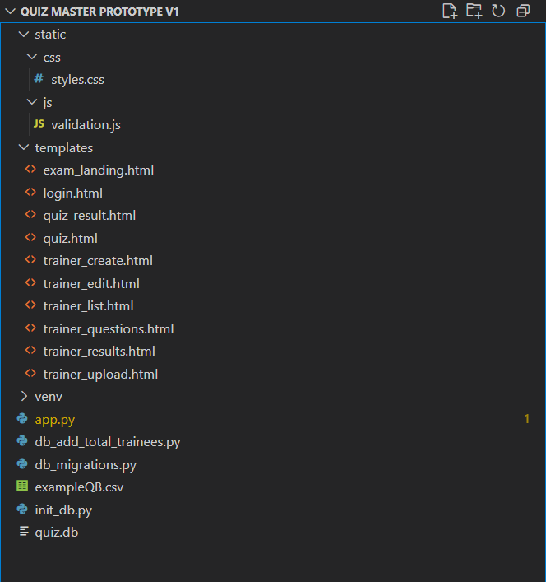**

**Pre-Requisites:**

* **Ensure Python 3.8+ is installed and python is on PATH.**
* **Create a virtual environment and activate it:**
  + **python -m venv venv**
  + **venv\Scripts\activate**
* **pip install flask**
* **Initialize the quiz.db (See Steps Below)**

**Run this once to create quiz.db (Initially it is not present in the directory):**

* **python init_db.py**
* **python db_migrations.py**
* **python db_add_total_trainees.py**

**To Run the app:**

* **python app.py**

